Computer Practical
File

2025-‘26

Name: Ved Kapadia Class: 11-Science
Roll number: 25
INDEX
S.no | Program name | Pg no.
1.
2.
3.
4.
5.
6.
7.
8.
9.
10.
11.
12.
13. | Write a program to check whether entered number is palindrome
14. | Write a program to check whether number is armstrong
15.
16.
17.
18.
19.
20.
21.
22.
23.
24.
25.
26.
27.
28.
29.
30.
31.
32.
33,
34.
35.
36.
37.
38,
39.
40.
41.
42.
43.
44.
45.
46.
47.
48.
49.
50.

Program #1- Input a welcome message and display it.

Code:-

# Input a welcome message and display it.
a=input("Write a welcome message")
print(a)

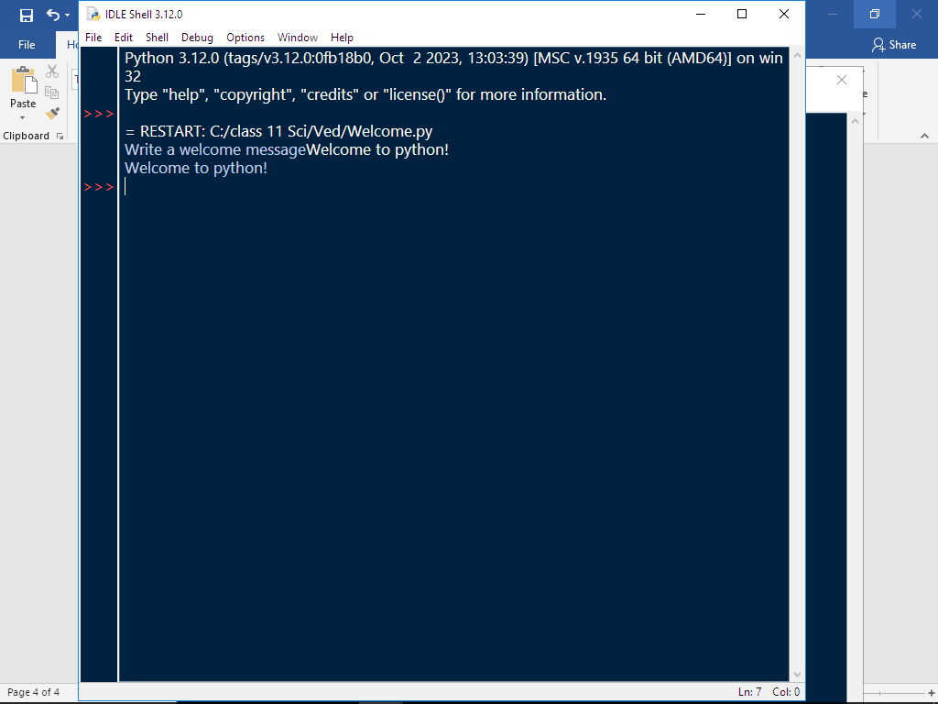

Program #2- PERIMETER AND AREA OF A CIRCLE

Code:-

# PERIMETER AND AREA OF A CIRCLE
r=eval(input('enter radius of circle'))
cir=2*22/7*r
print('Perimeter of given circle is', cir)
ar=22/7*r**2
print('Area of given circle is', ar)

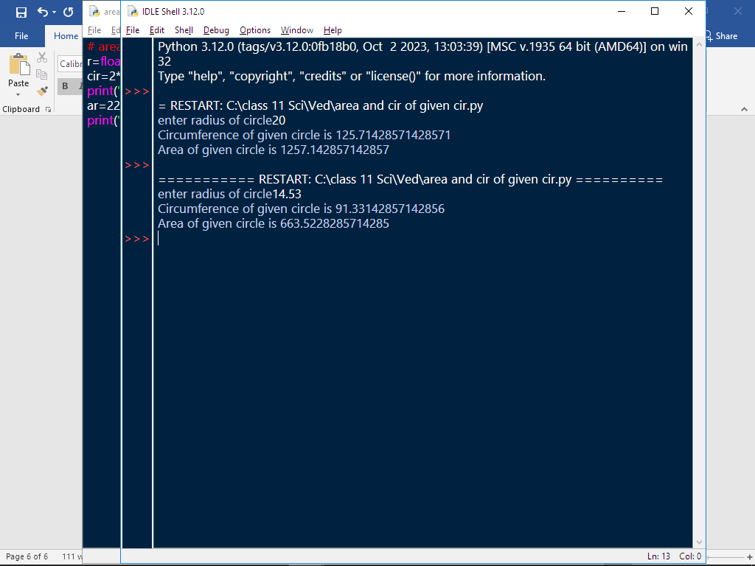

Program #3- Input three numbers and display the largest / smallest number.

Code:-
a=int(input("Enter no. 1"))
b=int(input("Enter no. 2"))
c=int(input("Enter no. 3"))
if a<b and a<c:
print(a, "is smallest")
elif b<a and b<c:
print(b, "is smallest")
elif c<a and c<b:
print(c, "is smallest")
elif a<=b and a<c:
print("first and second are smallest")
elif b<a and b<=c:
print(" second and third are smallest")
elif a<=c and a<b:
print(" first and third are smallest")
elif a==b and a==c:
print("all no's are equal")

if a>b and a>c:
print(a, "is biggest")
elif b>a and b>c:
print(b, "is biggest")
elif c>a and c>b:
print(c, "is biggest")
elif a>=b and a>c:
print("first and second are biggest")
elif b>a and b>=c:
print(" second and third are biggest")
elif a>=c and a>b:
print(" first and third are biggest")
elif a==b and a==c:
print("all no's are equal")

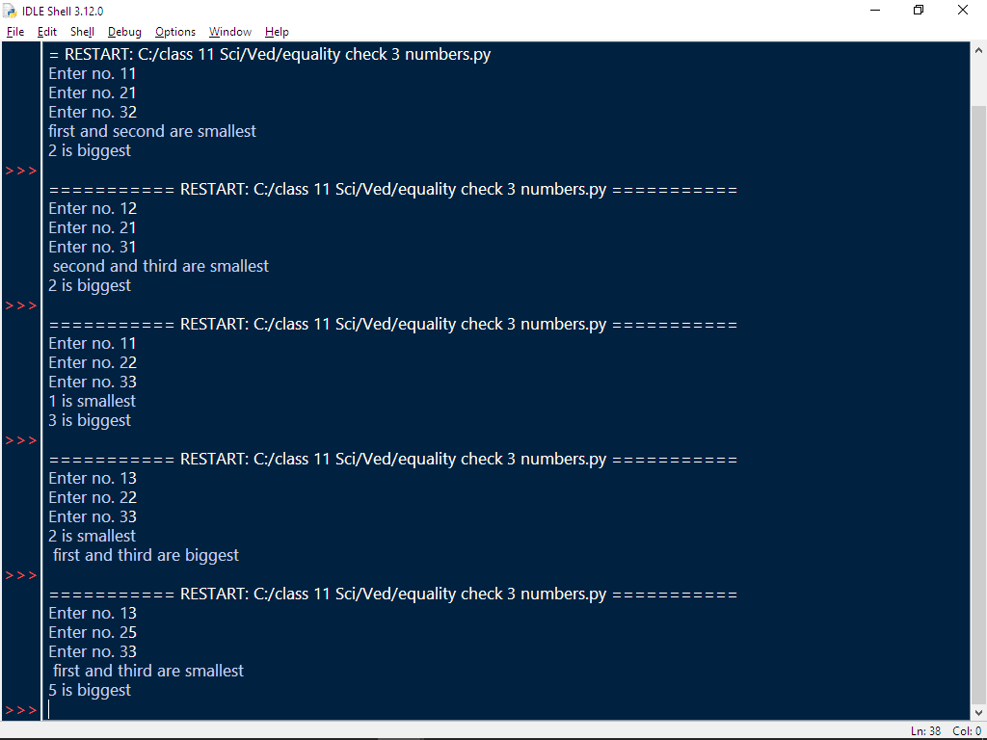

Program #4- Write a program TO CHECK ENTERED NUMBER IS ODD /EVEN.

Code:-

a=int(input("Enter a number"))
if a%2==0:
print("Number is even")
else:
print("Number is odd")

\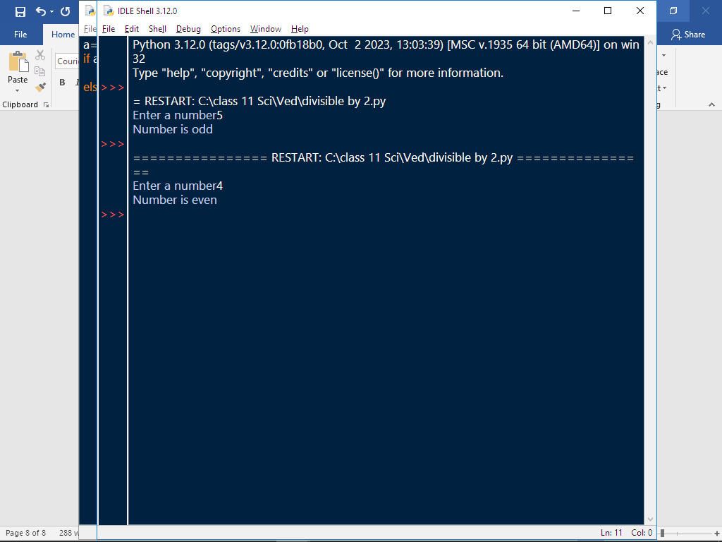

Program #5- Write a program to check for LEAP YEAR

Code:-

a=int(input("Enter your year in 4 digits"))
if a>999 and a<10000:
if a%4==0:
print("It is a leap year")
else:
print("It is not a leap year")
else:
print("You entered invalid year")

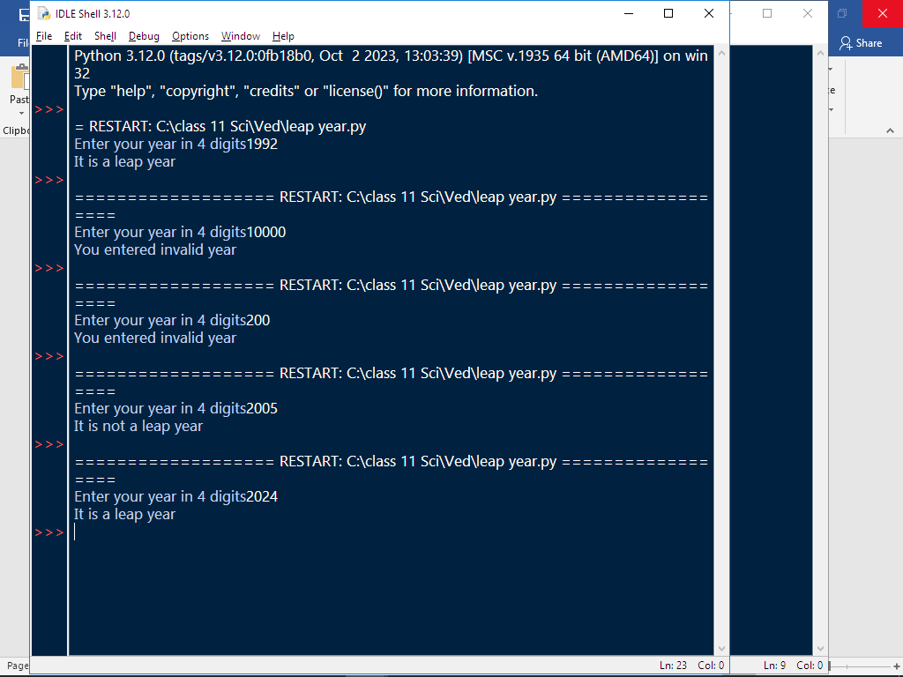

Program #6- Write a program to check entered character is vowels, consonants, uppercase, lowercase, special characters.

Code:-

a=input("Enter anything")
if a>="A" and a<="Z":
if a=="A" or "E" or "I" or "O" or "U":
print("vowel, uppercase")
else:
print("consonant, uppercase")
elif a>="a" and a<="z":
if a=="a" or "e" or "i" or "o" or "u":
print("vowel, lowercase")
else:
print("consonant, lowercase")
elif a>="0" and a<="9":
print("digit")
else:
print("special character")

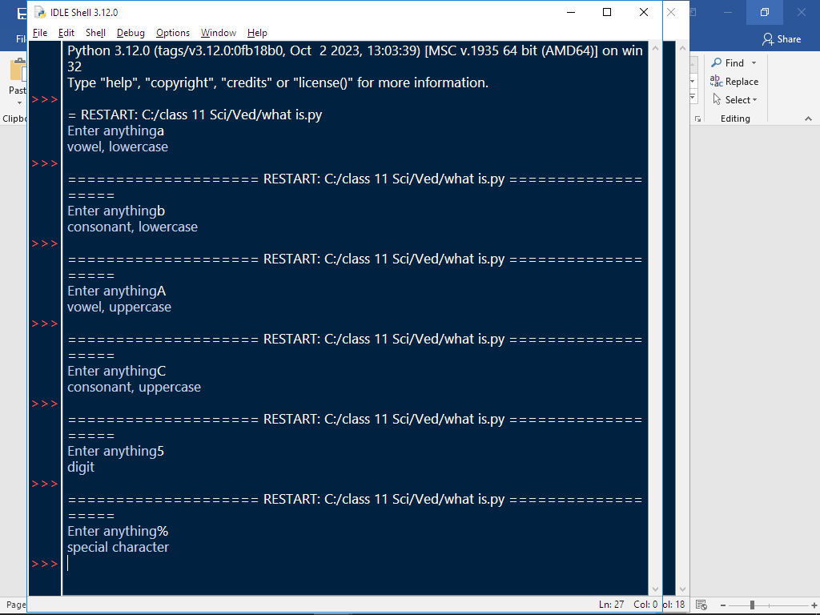

Program #7-

A telephone company charges for using telephone from their consumers according to the calls made (per month) as per the given tariff:

Numbers of calls Charge
Up to 50 calls No charge (free)
For next 100 calls exceeding 50 call Rs. 2 per call
For next 200 calls exceeding 150 call Rs. 1.50 per call + Previous 100 calls bill amount
More than 350 calls Rs. 1 per call + Previous 200 calls bill amount + previous 100 calls bill amount

Code:-
n=int(input("Enter no. of calls made"))
if n<0:
print("You have entered wrong number of calls, please enter correct value")
elif n<=50:
print("Your bill is free")
elif n<=150:
n=n-50
n=n*2
print("Your bill is",n)
elif n<=350:
n=n-150
b=n*1.5+200
print("Your bill is",b)
elif n>350:
n=n-350
b=300+200+n
print("Your bill is",b)
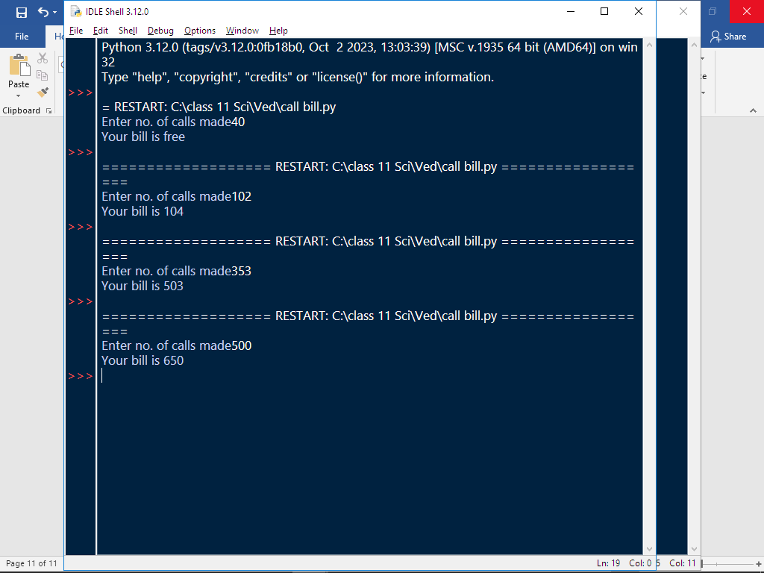

Program #8-

Write a program to input the value of x and n and print the sum of the following series:

Code:-

n=int(input("Enter value of n"))
x=int(input("Enter value of x"))
a=1
for b in range(2,n+1):
a=a+x**b
print("Sum of series=",a)

Program #9- Accept a decimal number and print its binary.

Code:-

